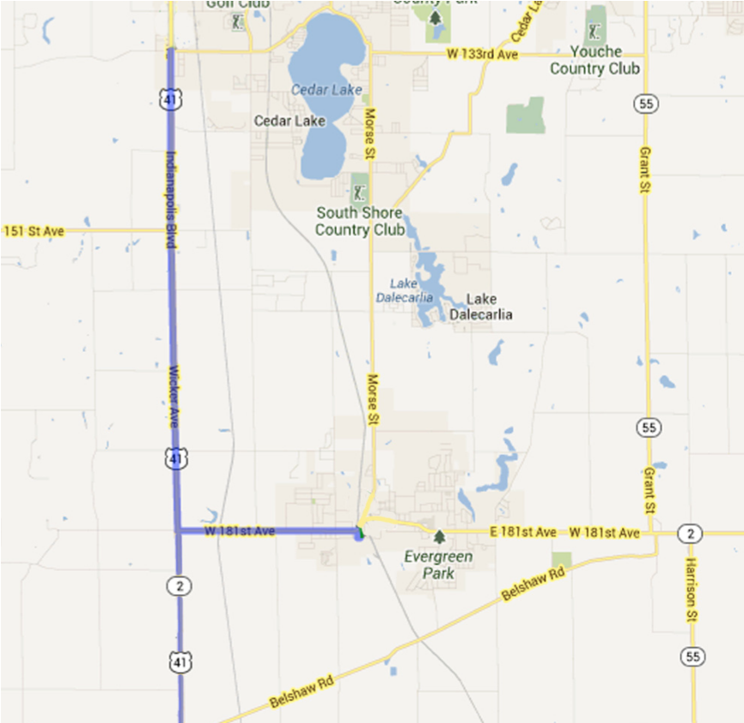
Directions to Parking
From 41 North or South to 195 West Oakley Ave
Turn east onto IN-2/181st Ave
Continue to follow IN-2 for 2.3 mi
Turn right (S) onto Liberty St for 0.1 mi
Turn left (E) onto W Oakley Ave
Destination will be on the right
Enter drive marked “5K Parking”

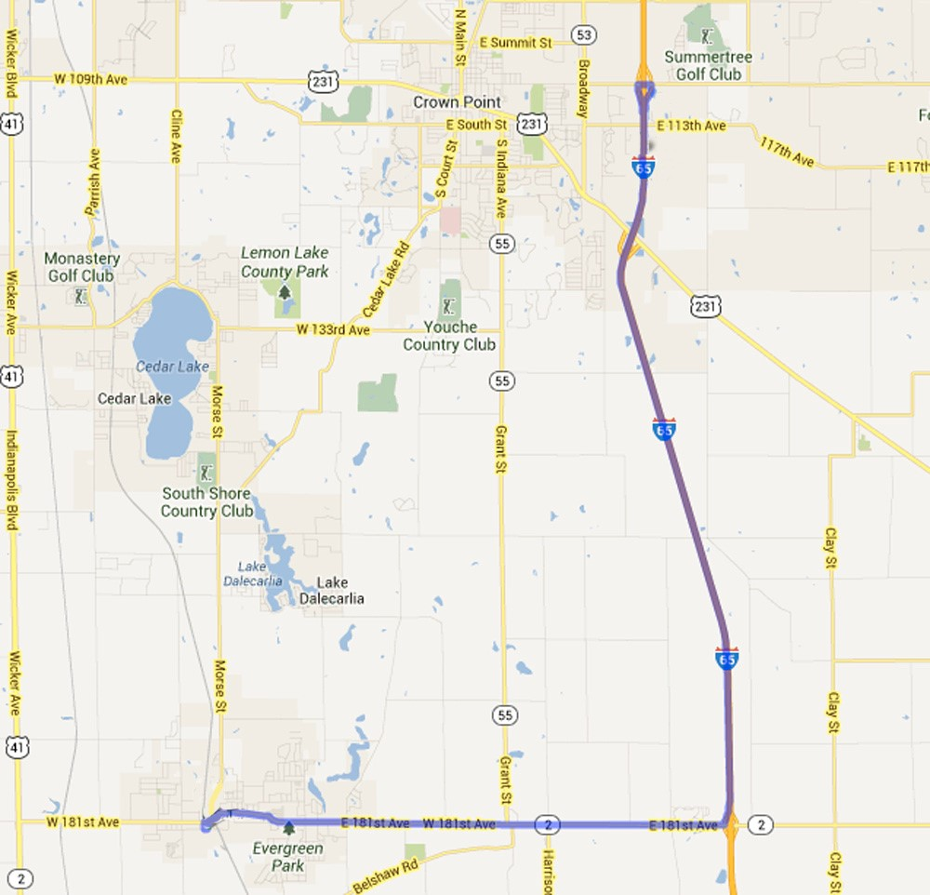

From 65 North or South to 195 West Oakley Ave
Take exit 240 for IN-2 toward Lowell
Turn west onto IN-2/181st Ave
Continue to follow IN-2 for 6.4 mi
Turn left (S) onto Liberty St for 0.1 mi
Turn left (E) onto W Oakley Ave
Destination will be on the right
Enter drive marked “5K Parking”

FOLLOW SIGNS IN PARKING LOT TO REGISTRATION

COURSE ROUTE
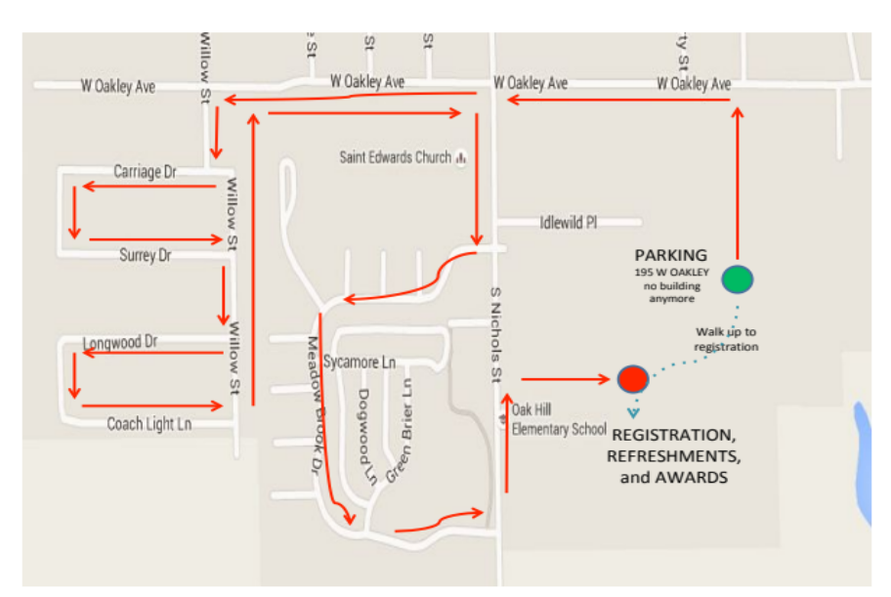

5K Run/Walk /WalkRun/Walk


Tri-Creek
Education Foundation
Lowell Labor Day Weekend 5K

Saturday, September 4, 2027
8:00 a.m. start

THANK YOU FOR
YOUR SUPPORT!
LOWELL LABOR DAY WEEKEND 5K
Saturday, September 4, 2027
DISCOUNTED PRICE & T-SHIRT if POSTMARKED BY AUGUST 8th
$25 Adult registration (15 yrs & older)
$23 Calumet Strider registration
$10 Youth registration (14 yrs & under)
$12 t-shirt YOUTH S M L XL (circle size)
$16 t-shirt ADULT S M L XL XXL $17 XXXL $18 XXXXL (circle size)
TOTAL ENCLOSED
POSTMARKED AFTER AUGUST – shirts not available
$30 Adult (15 yrs & older)
$28 Calumet Strider member
$10 Youth (14 yrs & under)
TOTAL ENCLOSED
NAME (please print) ______________________________________________________
GENDER M F DOB ________/________/________ AGE on 9/04/27___________
OR Athena/Clydesdale (please circle)
EMAIL ___________________________________________________________________
PHONE _____________________________________ *EMAIL AND/OR PHONE REQUIRED
Waiver Statement (Must be signed):
I, for myself, my heirs, executors, personal representatives, and assigns, hereby release Tri-Creek Education Foundation, the
Town of Lowell, Calumet Region Striders club and all government bodies or districts representing the geographic area(s) in which the 2027 Tri-Creek Education Foundation 5K Run/Walk is held, all sponsors, contractors, officials, and it’s and their officers, directors, trustees, employees, representatives, successors, and assigns (collectively, the “Released Parties”) from and against any and all claims under any theory (including without limitation, injury, illness, damage, loss or harm to me or my property or my death however caused) that may arise as a result of my participation in the Run/Walk, including activities that I engage in relating to the Run/Walk that occur before or after the Run/Walk. I attest and verify that I am physically fit and able to participate in a Run/Walk of this type. I grant my permission to the Released Parties to reproduce my name, likeness, image, personality and voice by any audio or visual recording technique now known or hereafter devised in connection with publicity and promotional activities connected to the Run/Walk and or released in all media. In case of emergency, I authorize the Released Parties to arrange for or provide such medical care assistance, treatment and/or services including without limitation surgery to me as they determine to be necessary. I hereby release, discharge, relinquish and hold harmless the Released Parties from any medical care, assistance, treatment or services to me at any time whether such services are provided by health care professionals, paramedics, or other persons.

Registration must be postmarked
by
August 8
to order
a t-shirt.

____________________________________________________________ _________________________
Participant’s Signature Date

____________________________________________________________ __________________________
Parent/Guardian Signature if under 18 Date

REGISTRATION
Online - https://runsignup.com/Race/IN/Lowell/LowellLaborDayWeekend5K
Download Form @ www.t-cef.org
Mail registration form with check payable to:
Tri-Creek Education Foundation, 2055 E Commercial Ave, Lowell, IN 46356
TO ORDER SHIRTS, REGISTRATIONS MUST BE POSTMARKED BY AUGUST 8th.
RACE DAY
Registration and shirt pick up ~ 6:30-7:30 a.m.
Ample parking and facilities are available on site.
COMPUTERIZED CHIP TIMING

Computerized chip timing by T&H Timing. Split times at every mile and water stations on the course. No pets, bicycles, in-line skates, roller shoes, scooters, skateboards or other vehicles allowed on the course. Strollers are welcome.
PROCEEDS
Proceeds from this event benefit the Tri-Creek Education Foundation, therefore no refunds. More information: t-cef.org or e-mail tcef@tricreek.k12.in.us.
CONTACT INFORMATION
Email: tcef@tricreek.k12.in.us Call/Text: (219) 808-1063
FB: Tri-Creek Education Foundation IG: tcef_lowell
AWARDS and DOOR PRIZES
Medals and door prizes will be presented immediately following the race. Winners must be present.
Awards presented to: Top overall male & female finishers
Top male & female masters
Top three finishers in each division (male & female)
AWARD DIVISIONS
0-8 | 9-10 | 11-12 | 13-14 | 15-18 | 19-24
25-29 | 30-34 | 35-39 | 40-44 | 45-49 | 50-54
55-59 | 60-64 | 65-69 | 70-74 | 75-79 | 80+

Athena & Clydesdale

