Directions to Parking

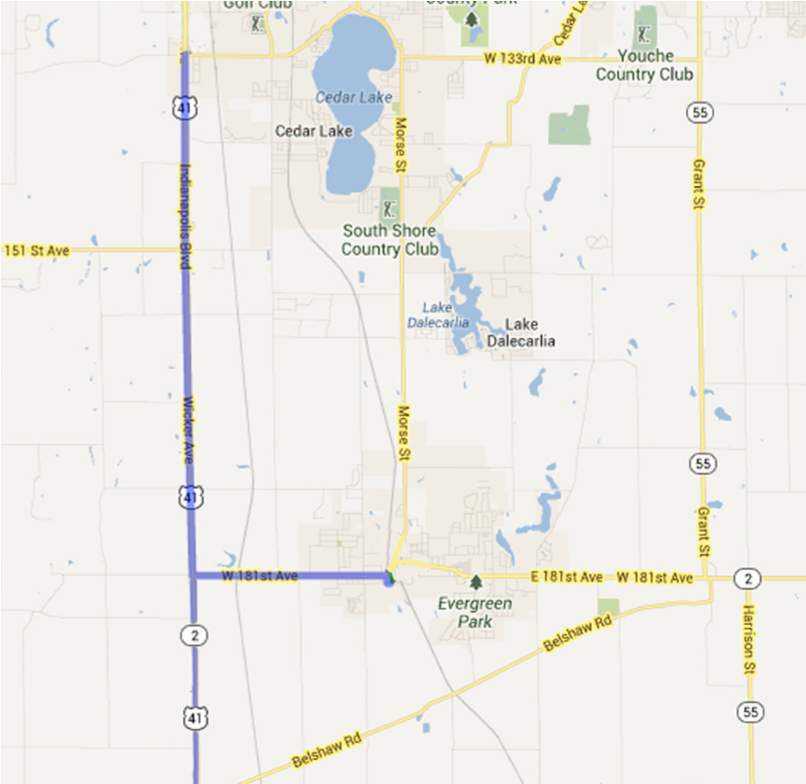

**From 41 North or South to 195 West Oakley Ave**

Turn east onto IN-2/181st Ave

Continue to follow IN-2 for 2.3 mi

Turn right (S) onto Liberty St for 0.1 mi

Turn left (E) onto W Oakley Ave

Destination will be on the right

Enter drive marked “5K Parking”

**From 65 North or South to 195 West Oakley Ave**

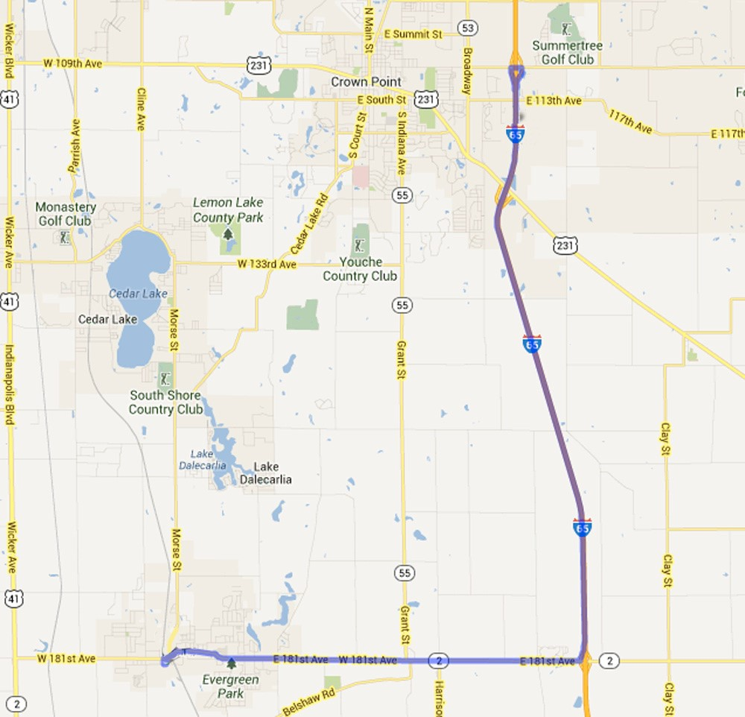

Take exit 240 for IN-2 toward Lowell

Turn west onto IN-2/181st Ave

Continue to follow IN-2 for 6.4 mi

Turn left (S) onto Liberty St for 0.1 mi

Turn left (E) onto W Oakley Ave

Destination will be on the right

Enter drive marked “5K Parking”

**FOLLOW SIGNS IN PARKING LOT TO REGISTRATION**

**COURSE ROUTE**



5K Run/Walk /WalkRun/Walk



**Tri-Creek**

**Education Foundation**

Lowell Labor Day Weekend 5K

Saturday, August 30, 2025

8:00 a.m. start

*THANK YOU FOR*

*YOUR SUPPORT!*

**LOWELL LABOR DAY WEEKEND 5K**

**Saturday, August 30, 2025**

DISCOUNTED PRICE & T-SHIRT if POSTMARKED BY AUGUST 9

*$25 Adult registration (15 yrs & older)*

*$23 Calumet Strider registration*

*$10 Youth registration (14 yrs & under)*

*$12 t-shirt* ***YOUTH*** *S M L XL (circle size)*

*$16 t-shirt* ***ADULT*** *S M L XL XXL $17 XXXL $18 XXXXL (circle size)*

*TOTAL ENCLOSED*

POSTMARKED AFTER AUGUST 9 – shirts not available

*$30 Adult (15 yrs & older)*

*$28 Calumet Strider member*

*$10 Youth (14 yrs & under)*

*TOTAL ENCLOSED*

**NAME (please print)** ______________________________________________________

**GENDER** **M F** **DOB** ________/________/________ **AGE** **on 8/30/25**___________

**OR Athena/Clydesdale (please circle)**

**EMAIL** ___________________________________________________________________

**PHONE**  _____________________________________ *EMAIL AND/OR PHONE REQUIRED

**TRI-CREEK SCHOOL** _______________________________________________ (see Awards and Prizes)

**Waiver Statement (Must be signed):**

I, for myself, my heirs, executors, personal representatives, and assigns, hereby release Tri-Creek Education Foundation, the

Town of Lowell, Calumet Region Striders club and all government bodies or districts representing the geographic area(s) in which the 2025 Tri-Creek Education Foundation 5K Run/Walk is held, all sponsors, contractors, officials, and it’s and their officers, directors, trustees, employees, representatives, successors, and assigns (collectively, the “Released Parties”) from and against any and all claims under any theory (including without limitation, injury, illness, damage, loss or harm to me or my property or my death however caused) that may arise as a result of my participation in the Run/Walk, including activities that I engage in relating to the Run/Walk that occur before or after the Run/Walk. I attest and verify that I am physically fit and able to participate in a Run/Walk of this type. I grant my permission to the Released Parties to reproduce my name, likeness, image, personality and voice by any audio or visual recording technique now known or hereafter devised in connection with publicity and promotional activities connected to the Run/Walk and or released in all media. In case of emergency, I authorize the Released Parties to arrange for or provide such medical care assistance, treatment and/or services including without limitation surgery to me as they determine to be necessary. I hereby release, discharge, relinquish and hold harmless the Released Parties from any medical care, assistance, treatment or services to me at any time whether such services are provided by health care professionals, paramedics, or other persons.

**Registration must be postmarked**

**by**

**August 9**

**to order**

**a t-shirt.**

____________________________________________________________ _________________________

Participant’s Signature Date

____________________________________________________________ __________________________

Parent/Guardian Signature if under 18 Date



**REGISTRATION**

**Online -** https://runsignup.com/Race/IN/Lowell/LowellLaborDayWeekend5K or

**Download Form @** www.t-cef.org

Mail registration form with check payable to:

Tri-Creek Education Foundation, 2055 E Commercial Ave, Lowell, IN 46356

*TO ORDER SHIRTS, REGISTRATIONS MUST BE POSTMARKED BY AUGUST 9*

**RACE DAY**

Registration and shirt pick up ~ 6:30-7:30 a.m.

Ample parking and facilities are available on site.

**COMPUTERIZED CHIP TIMING**

Computerized chip timing by T&H Timing. Split times at every mile and water stations on the course. No pets, bicycles, in-line skates, roller shoes, scooters, skateboards or other vehicles allowed on the course. Strollers are welcome.

**PROCEEDS**

Proceeds from this event benefit the Tri-Creek Education Foundation, therefore no refunds. More information: t-cef.org *or* e-mail tcef@tricreek.k12.in.us.

**CONTACT INFORMATION**

**Email:**  tcef@tricreek.k12.in.us **Phone or** **Text:** (219) 808-1063

**AWARDS and DOOR PRIZES**

*Medals and door prizes will be presented immediately following the race.* ***Winners must be present.***

Awards presented to: Top overall male & female finishers

Top male & female masters

Top three finishers in each division (male & female)

**AWARD DIVISIONS**

|  |  |  |  |  |  |
| --- | --- | --- | --- | --- | --- |
| 0-8 | 9-10 | 11-12 | 13-14 | 15-18 | 19-24 |
| 25-29 | 30-34 | 35-39 | 40-44 | 45-49 | 50-54 |
| 55-59 | 60-64 | 65-69 | 70-74 | 75-79 | 80+ |

Athena & Clydesdale