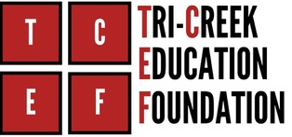

LHS INTERNATIONAL TRAVEL GRANT
GRANT ACCEPTANCE CONTRACT

- STUDENT NAME is selected to receive the LHS International Travel Grant in the amount of $2,114.50 for the school sponsored trip to LONDON AND PARIS, departing in March 2027. This amount will be paid up front by the Tri-Creek Education Foundation, Inc.

- The remaining amount of $2,114.50 program cost plus other costs not included through the travel company will be paid by the student. These may include but are not limited to: enrollment fee, late payment fees assessed by the travel company, passport/visa fees, baggage fees, tips, snacks and meals not covered by the trip itinerary.

- Twelve (12) monthly payments at $176.21 per month must be deposited by the student/parent directly into the student’s travel account with travel company (EF Tours).

- A standard trip cancellation policy is included in the trip program cost. I understand that I can purchase the premium policy at my own expense through the travel company. In the event of trip cancellation, refunded monies shall first go to the Tri-Creek Education Foundation, Inc. for the amount of the grant. Any remaining refunded amounts shall go to the student.

- I have reviewed the travel company cancellation policy and understand my obligations.

Student Signature Date

Parent Signature Date

Tri-Creek Education Foundation Date

Student Travel Account Number

